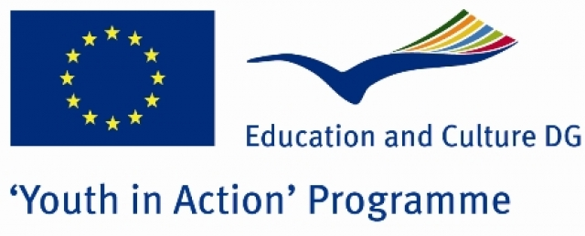

CALL FOR PARTNERS

„ ART house! „

Action 3.1. Youth Exchange
Cooperation with Neighbouring Partner Countries

Rustavi, Georgia
2010

Objective, Context and Motivation

„ART house” main aim is to create the place where young Georgian people in the Rustavi region can get an opportunity for self-realization and self-determination as an alternative how to spend their free time and to avoid bad habits such as alcoholism, drug addiction and possibility to get involved in different sort of crimes. There are no places in Rustavi region where youth can do any free time activities or get non-formal education. The biggest part of the population is unemployed and without any motivation of self-development. The lack of non-formal education and educative programs of international standards results as degradation of all society, especially - youngest part. Using experience and knowledge of the project’s participants, exchanging opinions and discussing about organising process, advertisement, music and modern art (graffiti, computer graphic etc), the project will accomplish its goal - to create „Rustavi Art house" for Rustavi youth where they can organise their free time activities, new music band concerts, art and photo exhibitions and do other creative things.

Activities and tasks

- Participants get to know each other, presentations, team building activities.
- To promote youth experience, exchange opinions and knowledge about advertisement, music and modern art.
- To inform youth and to promote discussions about creative ways how to spend their free time, to talk about possibilities how to develop their music talents and to give them a chance to be in touch with young people from different Europe countries.
- To create visually nice, colourful “Rustavi art house” using modern art elements, to establish a place together with Rustavi youth for new music band concerts, exhibitions and other creative activities.
- To make an interest in youth about “Art house” with different advertisement tricks and intercultural dialogue, so that they would visit the place and spend their free time there, also promote Youth In Action programme and possibilities.
- To organise „Rustavi art house” opening ceremony with live music concert, improvised music jam, art work exhibition and other shows.
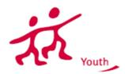

_________________________________________________________________________

Target Group

Participants - youngsters of different genders, ages, nationalities and backgrounds who are interested in modern art, advertisament, music, also in performances making and realisation, with different level of experience in various ways of creative initiatives. Also they are interested in issues of youth politicy, they have a wish to work in international team and in the creative way to define ideas which are current for the society.

Funding

70% of travel costs, 100% of food and lodging costs and exceptional costs such as actual costs covering visa, visa-related costs and vaccination costs, as well as costs related to participants with fewer opportunities/special needs will be covered.

Partners

All Youth in Action Program countries.
Firstly we are searching motivated NGO which could help us to submit our ready project!
As the project will be applied to the Youth in Action Programme, we kindly ask you to send us your singed and stamped Part III via email to liene.bekere@gmail.com

Contact

Liene Bekere
(Project Manager)
Liene.bekere@ gmail.com
+99595657380
Association “Georgian Youth for Europe”

_______________________________________________________________

